
 | LEVEL 2 -- TEST
 | Theme 10: Feelings
Full name: |  | Mark
Full name: | ..................................................................................................... | Mark
School: ............................................................................................................
Class: ................................................................................................................
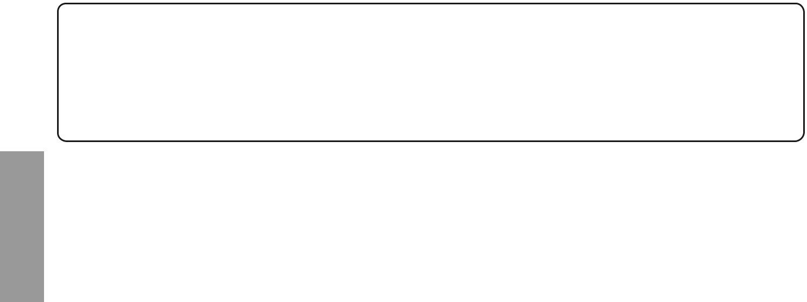

Reading & Writing

Part 1

- 2 questions -


Look and read. Put a tick ( ) or a cross (  ) in the box.
There are two examples.

Examples

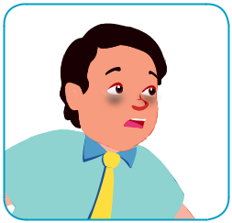

I'm tired.



I'm not so good.

Questions


1  I'm good.


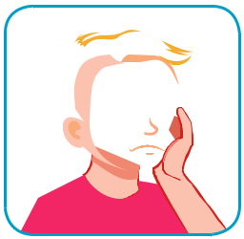

2  I'm happy.

Theme 10 Test © DTP Education Solutions


Reading & Writing

Part 2

- 2 questions -

Look and read. Write Yes or No.
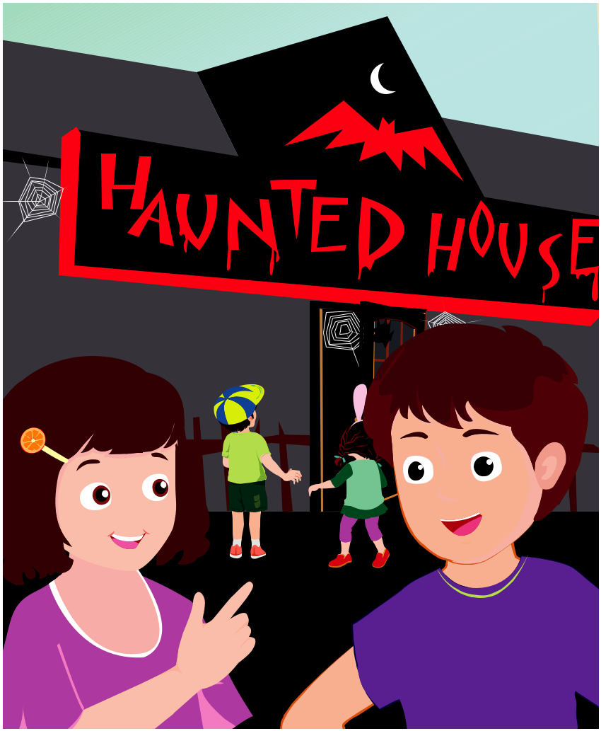

Examples
Are they excited? |  | Yes
Are they scared? |  | No

Questions

- Is Lisa happy?

- Are they sleepy?

Theme 10 Test © DTP Education Solutions

Reading & Writing

Part 3

- 2 questions -

Look at the pictures. Look at the letters. Write the words.

Example
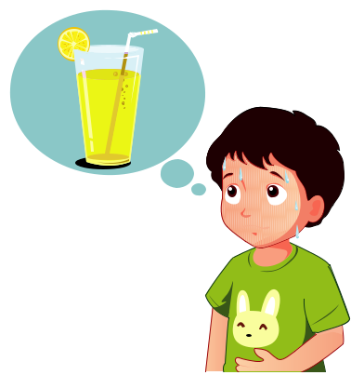

r | i | _{s} h | t | y | t
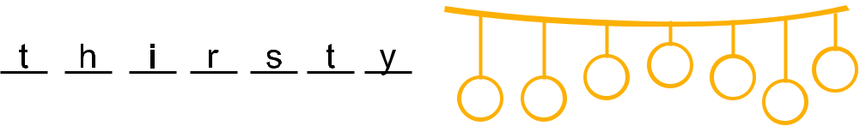

Questions

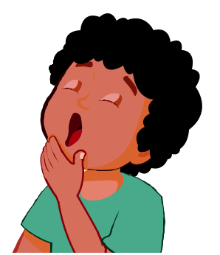

1 | l _{e y} ^{s}
e ^{p} | l _{e y} ^{s}

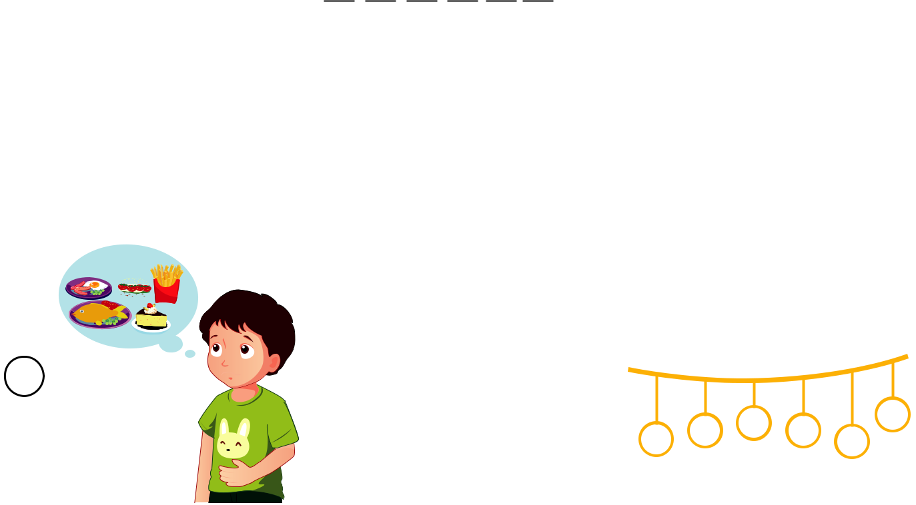

2
_{g} r ^{u} n _{h} ^{y}

Theme 10 Test © DTP Education Solutions

Reading & Writing

Part 4

- 2 questions -

Read the text. Choose a word from the box. Write the correct word next to numbers 1-- 2. There is one example.
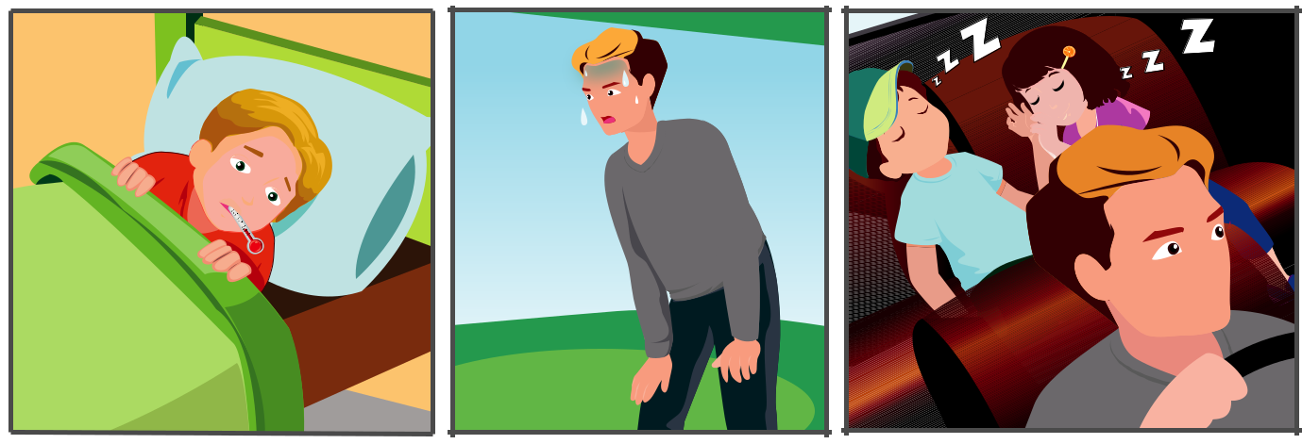

2
2

A Bad Day

Yesterday, the whole Brown family was feeling bad. Toby was feeling sick .

He ate some bad pizza. Mr. Brown played football so he was very (1)_________.

Lisa and Joe were very (2)_________ after playing all day.

Example

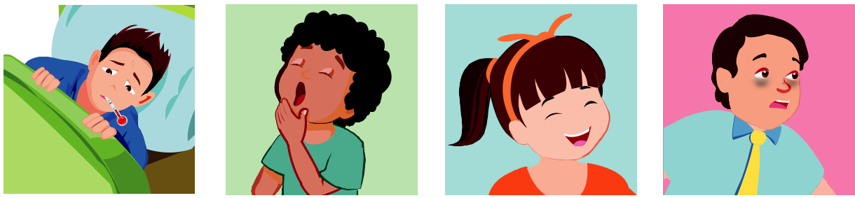

sick sleepy happy tired

Theme 10 Test © DTP Education Solutions

Reading & Writing

Part 5

- 2 questions -

Look at the pictures and read the questions.

Write one-word answers.

Examples
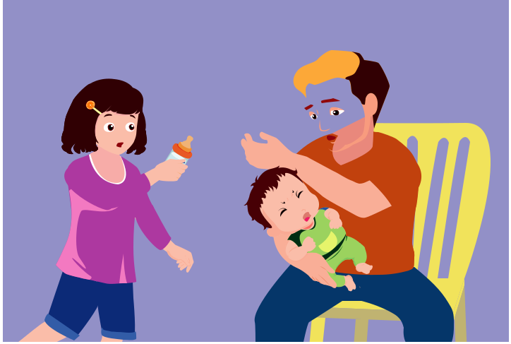

WAH...

WAH... 

What's wrong with Max?

He's hungry .

Is Max happy?

No, he isn’t .

Questions
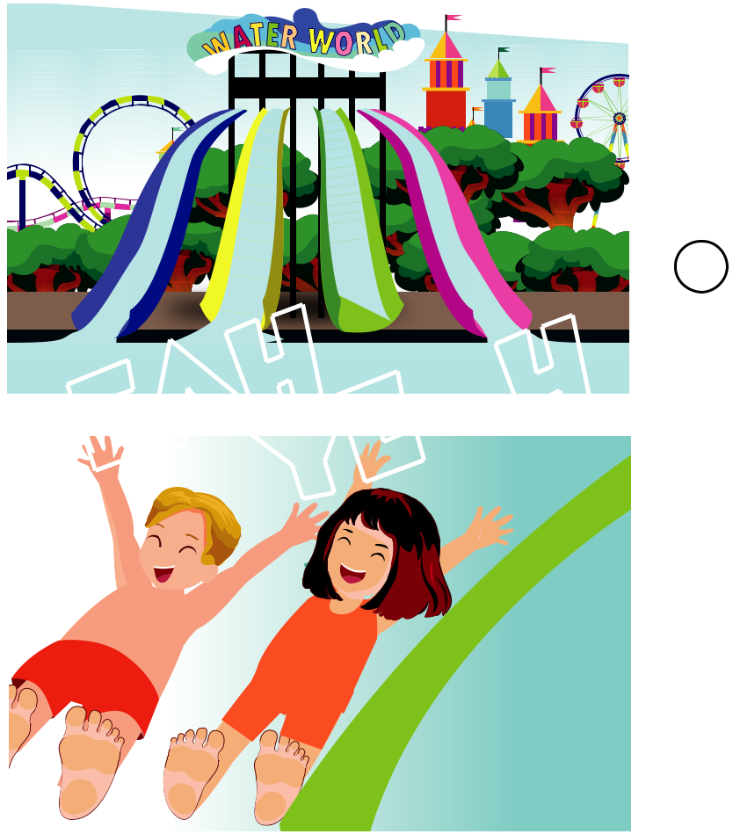

YEAHYEAH

- How are Toby and Amy? They feel ______________.

- Are they scared?

No, they _______________.

Theme 10 Test © DTP Education Solutions

